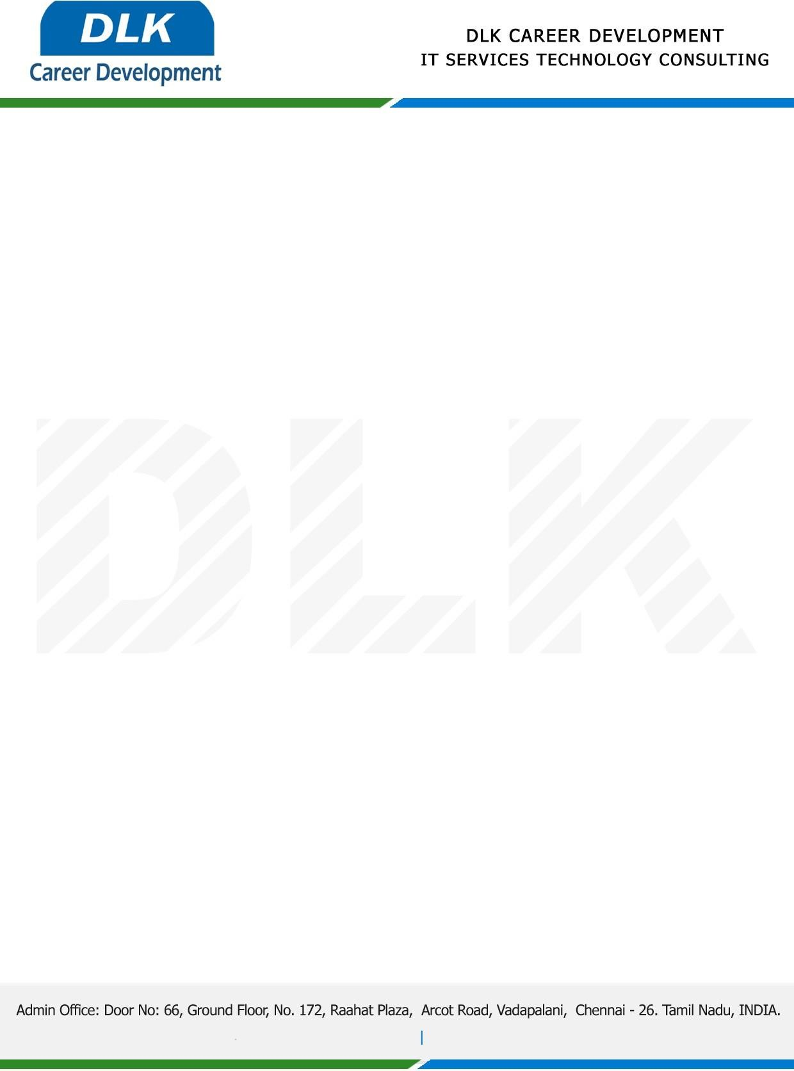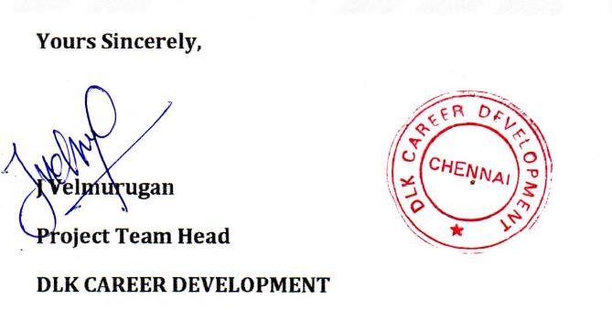

# Date: 07/ April /2023

**SUB: PROJECT COMPLETION CERTIFICATE**

This is to certify that **BCA-Department of Computer Application,** final year students at **University of Madras, Chennai** has Successfully Completed the Project Work under the domain of “**Python”** in our organization during the Period **(17th March 2023** to **07th April 2023).**

# Team Members:-

1. MS BIPNA C (REG NO 212003129)
2. MS DEEPIKA M (REG NO 212003131)
3. MS AKSHAYAPRIYA S(REG NO 212003126)

**Topic:** Emotion Detection with Facial Feature Recognition Using Cnn & Opencv.

We appreciate your interest in **DLK CAREER DEVELOPMENT**

# “Best Wishes for Your Future Endeavors “